NOTE: Please change the image for your report.
To change the image double click on the header.
Right click and select change picture. It is advised to use a image with a portrait orientation.

Heading 1 (insert research heading here)
  - R 201X/XXXX
XXXX 2017

Contents
Heading 2 style – 18pt Arial bold deep ocean blue 3
Heading 3 – 15pt Arial bold deep ocean 3
Heading 4 – 13pt Arial bold deep ocean 3
1 Heading 2 - using numbered headings 3
1.1 Heading 3 - numbered 3
1.1.1 Heading 4 - numbered 3
2 Numbered heading 3
2.1 Heading text 3
2.1.1 Heading text 3
About this document 3
List styles 3
Landscape pages and resizing footers 3
Figures and tables 3
Back cover or references 3

Figures
Figure 1 Figure caption style 3

Tables
Table 1 Table caption style 3

Heading 2 style – 18pt Arial bold deep ocean blue
Because Heading 1 is the document title, everything should start with Heading 2.

Heading 3 – 15pt Arial bold deep ocean

Heading 4 – 13pt Arial bold deep ocean

Heading 5 – 12pt Arial bold deep ocean

Heading 6 – 12pt Arial italic bold Deep ocean

Heading 7 – 12pt Arial italic Deep Ocean

Heading 8 – 11pt Arial Deep Ocean

Heading 9 – 10pt Arial Italic Deep Ocean
  - Heading 2 - using numbered headings
Because you will only have one Heading 1, the numbering starts with Heading 2 - numbered.
    - Heading 3 - numbered
Normal text
      - Heading 4 - numbered
Normal text
        - Heading 5 - numbered
          - Heading 6 - numbered
            - Heading 7 - numbered
              - Heading 8 - numbered
                - Heading 9 - numbered
  - Numbered heading
The numbering automatically changes.
    - Heading text
Normal text
      - Heading text
Normal text

About this document
This document shows you what styles are being used and guides you in using templates.
Use Heading 2 styles in you document for main headings.
Heading 1 style should only be used for the document title. This is so documents can be converted to the website easily in the future.
Heading shortcuts:
- Heading 1 = CTRL+ALT+1
- Heading 2 = CTRL+ALT+2
- Heading 3 = CTRL+ALT+3.
Normal text – 12pt Arial– Charcoal RGB(51,51,51)
The ‘blue’ colour is called Deep Ocen Blue – RGB (9,62,82)
If you need help using these styles contact the Communications Team.
Do:
- refer to and use the AFMA Style Guide
- ask the Communications Team if you want picture or colour changes
- not change the default styles of this template
- paste from other documents using “paste as plain text”
- 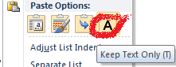
- use the default table styles
- use the default dot points
- consider accessibility guidelines when creating a document.

List styles
Unordered list:
- bullet 1
  - bullet 2
    - bullet 3
Ordered list:
- Item one
- Item two
- Item three
Shortcuts - move bullets using ALT + SHIFT+ left or right arrows.

Landscape pages and resizing footers
To insert a landscape page, use a section break.
To make sure the footer resizes on the landscape page, you will need to “unlink” it with the previous section. Do this by opening the footer on the new landscape page, and then in the “Page Layout” menu, choose the “Link to Previous” to unlink it. The footer will then automatically resize.
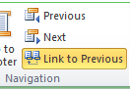

Figures and tables
Figures must include a caption above the figure.
Figure 1 Please use Caption style
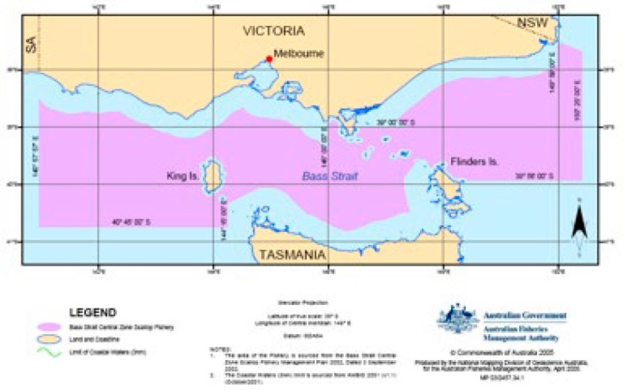

Table style insert table and the default table should show up. But you will need to apply “Table Heading” and “Table Text” to the table rows.
Table Heading
Table Text
Table 1 Please use Caption style

Back cover or references
Reference style AFMA, 2009. Bass Strait Central Zone Scallop Fishery Bycatch and Discarding Work Plan, 1st June, 2009 to 31st May, 2011. 22p.
AFMAb, 2009. Ecological Risk Management, Bass Strait Central Zone Scallop Fishery. 18p.
AFMAa, 2012. Bass Strait Central Zone Scallop Fishery,Review of the Bycatch and Discarding Work Plan, 1st June,
2009 to 31st May, 2011. 8p.
Haddon, M., Harrington, J.J. and Semmens, J.M., 2006. Juvenile Scallop Discard Rates and Bed Dynamics: Testing the Management Rules for Scallops in Bass Strait. Tasmanian Aquaculture and Fisheries Institute, Taroona, Tasmania.

