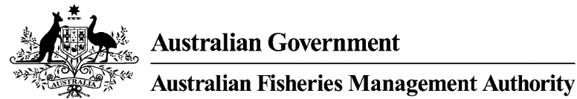

Reference: F2017/0050
9 June 2020

All ETBF Longline Concession Holders

Dear Longline Concession Holder,

Southern Bluefin Tuna (SBT) Zones – Management Arrangements for 2020
Enclosed is an information package on the SBT management arrangements for the 2020 season.
As in previous years, the current location of the SBT zone is posted on the AFMA website at http://www.afma.gov.au/fisheries-services/sbt-zones/. The AFMA website will also provide details of any management arrangements that you must comply with.
It is the operator’s responsibility to be aware of the location of the SBT zone and ensure they have adequate quota holdings and a fully operational electronic monitoring system to enter the SBT zone.
If you have any questions regarding the management arrangements associated with the SBT zone, or the location of the SBT zone during the fishing season please contact me on (02) 6225 5338 or 0417 425 771.

Yours sincerely

Matt Daniel
Southern Bluefin Tuna Fishery Manager

