POSITION DESCRIPTION

Position title: | Fisheries Observer
Classification: | APS 2
Branch: | Fisheries Information and Services Branch
Section: | Observers
Location: | Various
Nature of employment: | Irregular or intermittent
Working arrangements: | Casual
Salary range: | $281.48 - $300.42 per day plus at-sea allowances
Position number: | Various
Security classification of the position: | Baseline
Contact Officer | email: | observers@afma.gov.au

WHY JOIN AFMA?
What we offer our people

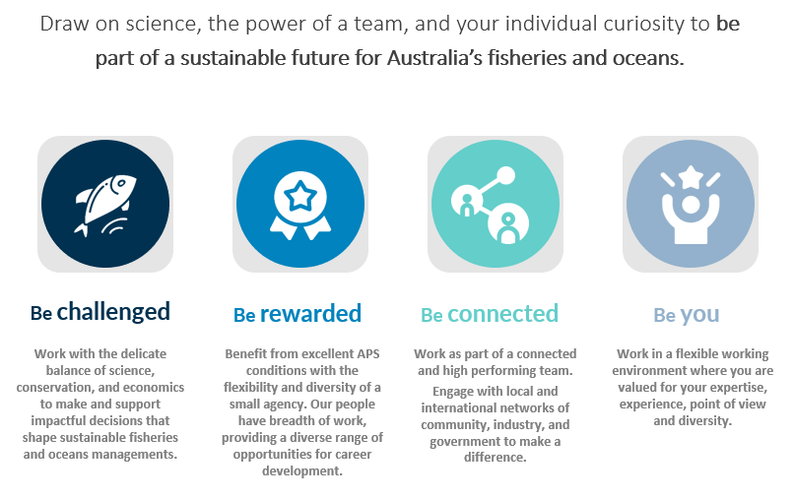

WHO ARE WE LOOKING FOR TO JOIN US?
Our ideal candidate

We are looking for someone who:
- Can demonstrate their ability to work independently in challenging conditions
- Possesses excellent communication skills
- Is a proficient user of computers
- Understands the Australian fishing industry
More details on our ideal candidate are provided on page 5.
ABOUT US
About the organisation and team you would join

About AFMA
The Australian Fisheries Management Authority (AFMA) aims to provide ecologically sustainable and economically efficient Commonwealth fisheries, through understanding and monitoring Australia’s marine living resources and regulating and monitoring commercial fishing, including domestic licensing and deterrence of illegal foreign fishing.
About the branch
The Fisheries Information and Service Branch (FISB) is AFMA’s innovation hub and delivers AFMA’s core services and monitoring programs including the observer program, licencing, and business intelligence.
About the team
The Observer Program is one of two at sea monitoring programs used to collect verified scientific data that underpins evidence-based fisheries management decisions across Commonwealth fisheries. Data collected includes catch, effort, deployment of mitigation measures, interactions with protected species and biological data such as otoliths and length measurements.
Fisheries observers are placed onboard Commonwealth fishing vessels or undertake port monitoring. The data collected by the Observer Program is used in stock assessments and to monitor Commonwealth fisheries management arrangements.
The Observer Program deploys fisheries observers from their home locations into any of the 24 Commonwealth fisheries across the Australian Fishing Zone and/or on the high seas or into the Southern Ocean.
The Canberra based Observer administration team provides the support to the fisheries observers, managing the deployments and liaising across AFMAs business areas regarding the observer needs of each fishery. You will report to AFMA’s Observer Program Manager.

THE POSITION
About the role and what you will do

The position
AFMA deploys observers on a variety of commercial fishing vessels in and out of the Australian Fishing Zone domestically and internationally. The primary functions of the role include observing and documenting commercial fishing catches, collecting vessel, technical and biological data which is not normally obtainable through vessel logbooks, monitoring operations and documenting interactions with threatened, endangered and protected species (TEPs).
Working as a fisheries observer is a unique, adventurous and rewarding position that takes place in some of the most remote locations around Australia, on the High Seas and in the Antarctic and sub-Antarctic. The position provides our staff with the opportunity gain valuable field experience, an understanding of life at sea and the ability contribute to the sustainable management of living marine resources.
The position offers the opportunity an excellent work-life balance. Observers are based remotely from the Canberra office and successful applicants are deployed from their home location. Working arrangements are flexible with Observers able to nominate for greater deployments and remuneration is extremely competitive, based on a daily rate while deployed, plus allowances.
Observers are required to undertake work at sea, often in challenging conditions. The work can be physically and mentally demanding and can include exposure to cold and wet environments, rough seas and cramped living quarters.
Observers are required to regularly liaise and work with industry, management, peers and office based AFMA staff. The role also includes port-based sampling, and all aspects of the position are performed under limited supervision.
What you will do
In addition to meeting the work level standards (WLS) of the position classification, and seeking assistance from Senior Observers and management on more complex matters, the duties are:
1. Undertake regular work at-sea under challenging conditions with
limited supervision.
2. Collect vessel, technical and biological data.
3. Monitor environmental impacts by the vessel and its fishing gear.
4. Monitor vessel compliance with their permit conditions.
5. Verify catch and effort data submitted by the vessel in accordance with its
fishing permit conditions.
6. Participate in research programs supporting fisheries management and other Agencies for example, fish tagging and surveys and enter data and prepare end of trip reports.
7. Liaise with fishers with respect to observer program activities.
8. Monitor compliance with respects to marine pollution (MARPOL).

OUR IDEAL CANDIDATE
What we are looking for in a candidate

Capabilities
We are looking for someone with:
- Demonstrated experience in working independently (for example, remotely/at sea) under difficult conditions with limited supervision.
- Effective oral and written communication and strong liaison skills including a demonstrated ability to prepare concise structured written reports.
- Skills and familiarity with a suite of technical applications including Word, Excel and database packages.
- A good understanding of the Australian Fishing Industry and the role of the Commonwealth in fisheries management.
Essential requirements
Successful applicants will be required to:
- Undergo a police record check and obtain and maintain a security clearance at a specified clearance level.
- Complete a medical and functional fitness assessment (employment is conditional on being able to meet AFMA’s medical standards).
- Complete and pass a pre-employment psychometric assessment.
- Travel nationally and/or internationally and be regularly deployed at sea, often at short notice. Please note some at sea duties will require the applicant to be at sea for up to three months.
- Participate in and obtain mandatory training requirements (for example, Sea Safety, Remote First Aid and Swim test).
- Hold or ability to obtain and maintain a valid Australian Passport.
Please note applicants must not hold or have held shares or been employed in Commonwealth fisheries in the previous 12 months.
All applicants must be Australian citizens. AFMA staff are employed under the Australian Public Service Act 1999.
Desirable requirements
- Knowledge of research methodologies and experience in the collection of associated scientific data preferably with experience in at sea biological sampling.
- A certificate, tertiary qualification or relevant experience in Natural Resource Management, Marine Biology, Environmental Science or related discipline will be highly regarded.
- Knowledge and understanding of Australia’s commercial fishing industry
- An understanding of AFMA’s legislative objectives, and a commitment to both diversity and work, health and safety principles.

APPLYING FOR THE ROLE
How to submit an application

How to apply for the role
As part of your application, you must provide:
- Complete an application through our Temporary Employment Register
- Your CV
We are looking for specific and relevant examples that demonstrate your skills, knowledge, and, if applicable, your experience in working across Commonwealth and State agencies.
Please check our website Working at AFMA for more information on how to apply.
Assessment process
The selection process for this position is merit-based and will include an assessment of:
- your application
- an interview (where applicable)
- referee checks (where applicable)

Criminal record check
This position requires an Australian Federal Police Criminal Record Check
Security clearance
The position requires the successful candidate to hold a valid security clearance that can be upgraded or downgraded to the required level or be able to obtain and maintain a security clearance at the required level.
Need more information?
- Find out more about the role by speaking to the contact officer
- Learn more about AFMA
- Subscribe to AFMA’s news feed

