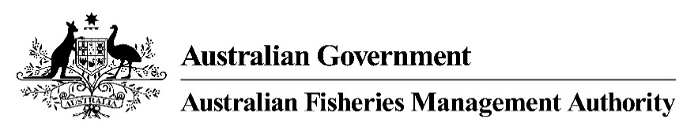

MAC MEMBERS

TRAVEL REIMBURSEMENT GUIDE and MILEAGE RATES 2022-23

Official Travel by Office Holders of Management Advisory Committees
Remuneration Tribunal (Official Travel) Determination 2022 effective from 28 August 2022 and available on their website at http://www.remtribunal.gov.au

Under Fisheries Management Paper No. 1, MAC members are entitled to be paid travelling expenses reasonably incurred in connection with MAC business. The AFMA member can advise on what constitutes MAC business.

Economy airfares and accommodation are booked and paid for directly by AFMA (under whole-of Australian-government travel services). In relation to meals and other expenses incurred by MAC members undertaking official travel, members will not be out of pocket for reasonable receipted expenses as prescribed under the AFMA travel policy. Please note AFMA has recently updated the policy on the purchase of alcohol. Please do not claim any reimbursement for alcohol.

To claim reimbursement for expenses incurred while on MAC business, members must provide AFMA with the below completed claim form with supporting documentation such as tax invoices for those expenses not paid directly by AFMA, for example incidentals such as taxis and parking. The completed claim form must be sent to the relevant AFMA Executive Officer to process the claim. Members will be asked to resubmit any claims that do not meet the test of reasonable expense or do not provide the required supporting documentation. It is important to send in claims within 14 business days of MAC meetings so that they can be processed promptly. These processes are designed to ensure the efficient and cost effective use of public money, sourced in this case from both the Commonwealth Government and from fishery-based levies.

Reasonable expense guidance

Dinner | $61.95
Lunch | $44.25
Breakfast | $31.25
Incidentals | $29.20

Motor vehicle allowances

A rate of 78 cents per kilometre will be paid to the MAC member where a private car is used to travel on official MAC business.

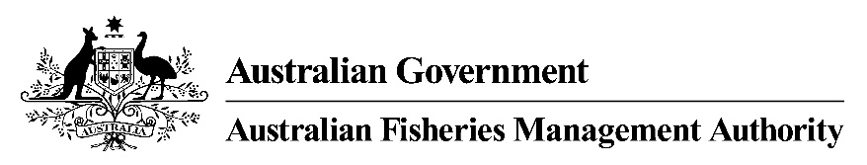

CLAIM FOR EXPENSES AND ALLOWANCES FOR ATTENDANCE AT AN AFMA COMMITTEE MEETING

DETAILS OF MEMBER
Name: ABN:
Address:
Phone: Fax: Email:

DETAILS OF MEETING
Name of Committee:
Meeting Place: Date: Time:

1a. DETAILS OF TRAVEL
Start/Place: Time: Date:
End/Place: Time: Date:
Was this travel by the most direct route?
If no, please explain:
Method of travel (please tick): Plane Vehicle (go to section 2)

1b. ACCOMMODATION and MEALS PROVIDED (by AFMA)
Number of nights’ accommodation - Number of breakfasts - Number of lunches - Number of dinners –

NOTE: FLIGHT TRAVEL
In accordance with the AFMA Travel Policy 2017, it is mandatory that flights be booked using AFMA’s preferred travel provider (QBT) to comply with the Whole of Australian Government travel arrangements. Fares are billed to AFMA and do not require re-imbursement.

2. DETAILS OF VEHICLE
Distance (kilometres) travelled by direct route:

3. DETAILS OF EXPENSES (attach tax invoices*)
Taxi - $ Parking - $ Other - $

CLAIM SIGNED BY (MAC member in attendance): DATE:

AFMA USE ONLY (Staff to complete and have signed by Section 23(3) delegate then forward to Finance for payment)
1a. Number of complete days claimed - 1b. Less accommodation provided - $ Less meals provided - $ Total Travel Allowance (6410) - $
2. Mileage Rate (c/km) - Total (6430) - $
3. Expenses* - Taxi (6433), Parking (6435), Other (as above) Total - $
TOTAL AMOUNT PAYABLE (INC GST) - $
COST CENTRE, PROJECT, ANALYSIS CODES (D / _ _ _ _ / (as above) / _ / _ _ _ _ _ _):
ATTENDANCE VERIFIED BY (PRINT NAME):

Section 23(3) APPROVAL (PRINT NAME & APS Level):
SIGNATURE: DATE:

Official MAC members do not need to provide an ABN. Costs should be entered including GST, where applicable
AFMA can recover GST on reimbursements where an original tax invoice is attached
If the member’s business is paid then the member must provide the business’ ABN
AFMA can recover the GST from payments to those members only if they have signed an RCTI agreement or provide their own tax invoice

