d

candidate information package

## Fisheries Observer APS 2-3

Correct as of April 2025

Why join afma?

## What we offer our people

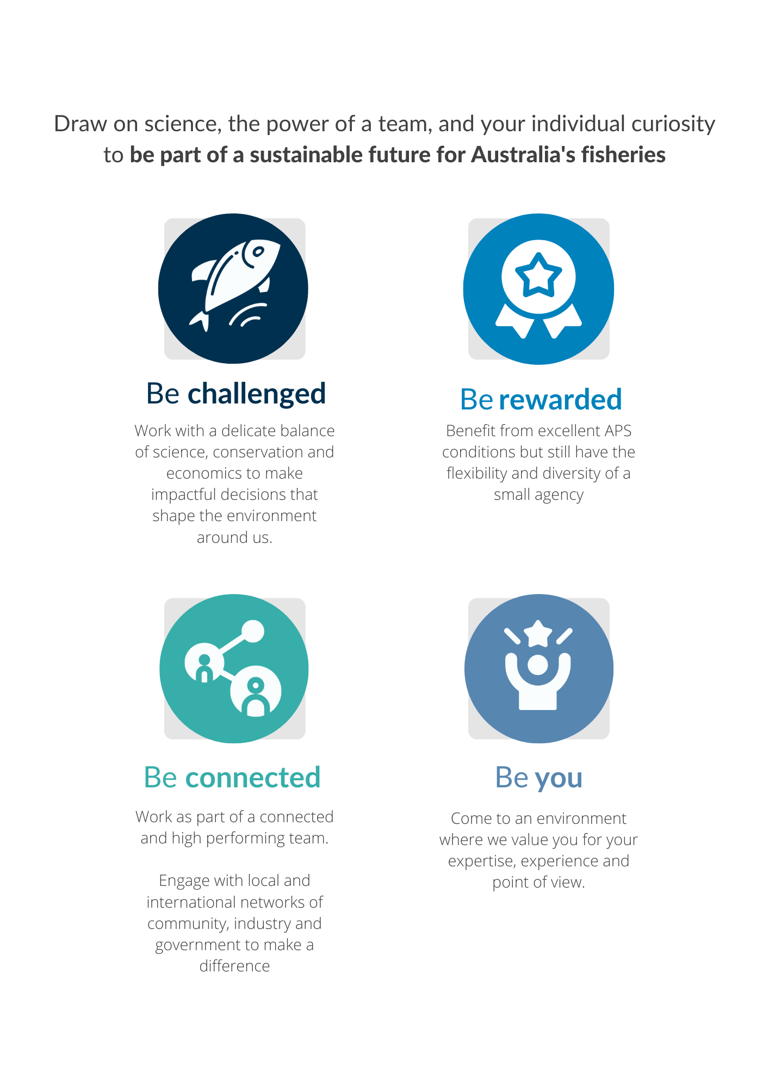

the position

## An overview of the position

|  |  |  |
| --- | --- | --- |
| Position title: | Fisheries observer | |
| Classification: | APS 2-3 | |
| Branch: | Fisheries Information and Services Branch | |
| Section: | Observers | |
| Location: | Various | |
| Nature of employment: | Irregular or intermittent | |
| Working arrangements: | Casual | |
| Salary range: | $316.53 - $376.51 per day plus at-sea allowances, TOIL and 15.4% super | |
| Position number: | Various | |
| Security classification: | Baseline | |
| Contact officer: | name: | Henry Oak |
| phone: |  |
| email: | observers@afma.gov.au |

Who are we looking for?

## Our ideal candidate

We are looking for someone who:

* can demonstrate their ability to work independently in challenging conditions
* possesses effective oral and written communication and strong liaison skills
* has a demonstrated ability to collect and synthesise scientific data to produce concise, structured written reports
* has a good understanding of the Australian fishing industry and Commonwealth fisheries management.

*More details on our ideal candidate are provided on* *page 6*

about us

## About the organisation and the team you would join

### About AFMA

The Australian Fisheries Management Authority (AFMA) aims to provide ecologically sustainable and economically efficient Commonwealth fisheries, through understanding and monitoring Australia’s marine living resources and regulating and monitoring commercial fishing, including domestic licensing and deterrence of illegal foreign fishing.

### About Fisheries Information and Services branch

The Fisheries Information and Services Branch (FISB) is AFMA’s innovation hub. Along with delivering core services such as data management, licencing and quota management services, the branch also administers a range of monitoring programs. This includes the observer program which safely deploys our at-sea scientific observers, port monitoring that collects biological information important for stock assessments and the electronic monitoring program (such as cameras on boats) to monitor and verify at-sea fishing activities. In addition to the collection and management of this empirical data, the branch also provides business intelligence and analytics capability together with operational policy support.

Along with these core functions, the branch is also responsible for delivering AFMA’s Data Transformation and Electronic Program (the Program). The Electronic Monitoring (EM) component of the Program will expand the use of EM across Commonwealth fisheries, enabling the collection and use of fine-scale data for evidence-based decision making and risk assessment. The Data Transformation (DT) component of the Program will modernise the IT infrastructure and systems that underpin and support the collection and integration of AFMA’s fisheries data with greater self-service and 24/7 access for industry. The delivery of this Program collectively will be a step change for fisheries management in Australia and globally.

### about The Observer team

The Observer Program is one of two at-sea monitoring programs used to collect verified scientific data that underpins evidence-based fisheries management decisions across Commonwealth fisheries. Data collected includes catch, effort, deployment of mitigation measures, interactions with protected species and biological data such as otoliths and length measurements.

Fisheries observers are placed onboard Commonwealth fishing vessels or undertake port monitoring. The data collected by the Observer Program is used in stock assessments and to monitor Commonwealth fisheries management arrangements.

The Observer Program deploys fisheries observers from their home locations into any of the 24 Commonwealth fisheries across the Australian Fishing Zone and/or on the high seas or into the Southern Ocean.

The Canberra based Observer administration team provides the support to the fisheries observers, managing the deployments and liaising across AFMAs business areas regarding the observer needs of each fishery. You will report to AFMA’s Observer Program Manager.

the position

## About the role and what you will do

### the observer role

AFMA deploys observers on a variety of commercial fishing vessels in and out of the Australian Fishing Zone domestically and internationally. The primary functions of the role include observing and documenting commercial fishing catches, collecting vessel, technical and biological data which is not normally obtainable through vessel logbooks, monitoring operations and documenting interactions with threatened, endangered, and protected species (TEPs).

Working as a fisheries observer is a unique, adventurous, and rewarding position that takes place in some of the most remote locations around Australia, on the High Seas and in the Antarctic and sub-Antarctic. The position provides our staff with the opportunity to gain valuable field experience, an understanding of life at sea and the ability contribute to the sustainable management of living marine resources.

The position offers the opportunity for an excellent work-life balance. Observers are based remotely from the Canberra office and successful applicants are deployed from their home location. Working arrangements are flexible with Observers able to nominate for greater deployments and remuneration is extremely competitive, based on a daily rate while deployed, plus allowances.

Observers are required to undertake work at sea, often in challenging conditions. The work can be physically and mentally demanding and can include exposure to cold and wet environments, rough seas, and cramped living quarters.

Observers are required to regularly liaise and work with industry, management, peers, and office based AFMA staff. The role also includes port-based sampling, and all aspects of the position are performed under limited supervision.

### what you will do

In addition to meeting the work level standards [WLS](http://www.apsc.gov.au/publications-and-media/current-publications/worklevel-standards) of the position classification, the duties are to:

* undertake regular work at-sea under challenging conditions with limited supervision
* collect vessel, technical and biological data
* monitor environmental impacts by the vessel and its fishing gear
* monitor performance for permit conditions
* verify catch and effort data submitted by the vessel in accordance with its fishing permit conditions
* participate in research programs supporting fisheries management and other agencies, such as fish tagging and surveys
* enter data and prepare end of trip reports
* liaise with fishers with respect to observer program activities.

our ideal candidate

## What we are looking for in a candidate and essential training and certification requirements you will need to possess or obtain when you commence with us

### essential capabilities

We are looking for someone with the following capabilities:

* Demonstrated experience in working independently (such as remotely/at sea) under difficult conditions with limited supervision.
* Effective oral and written communication and strong liaison skills including a demonstrated ability to prepare concise structured written reports.
* Proficiency and familiarity with a suite of technical applications including Microsoft Word and Excel and relevant database packages.
* Good understanding of the Australian Fishing Industry and the role of the Commonwealth in fisheries management.
* An understanding of AFMA’s legislative objectives, and a commitment to both diversity and work, health, and safety principles.

### desirable capabilities

A candidate with the following capabilities is desirable:

* Knowledge of research methodologies and experience in the collection of associated scientific data, preferably with experience in at-sea biological sampling.
* A certificate, tertiary qualification or relevant experience in Natural Resource Management, Marine Biology, Environmental Science, or related discipline will be highly regarded.

### training and certification requirements

This position requires the applicant to either possess or be willing to attain the following:

* Undergo a police record check and obtain and maintain a security clearance at a baseline clearance level.
* Complete a medical and functional fitness assessment at regular specified intervals (employment is conditional on being able to meet and maintain AFMA’s medical standards).
* Travel nationally and/or internationally and be regularly deployed at sea, often at short notice. *Please note some at-sea duties will require the applicant to be at sea for up to three months.*
* Participate in and obtain mandatory training requirements, including Sea Safety and Remote First Aid.
* Hold or have the ability to obtain and maintain a valid Australian Passport.

Attainment of these requirements is a condition of employment. AFMA will provide these to an employee upon their commencement (if they do not already possess them).

Please note applicants must not hold or have held shares or been employed in Commonwealth fisheries in the previous 12 months to be eligible for consideration.

Pre-employment requirements for this position include:

* a psychometric assessment
* medical and functional fitness assessments.

applying for this role

## How to submit an application and additional information on the assessment process

### what you need to provide

As part of this application, you must provide:

* your CV
* a ‘One-Page Pitch’.

The **One-Page Pitch** is a 500–600-word statement outlining why you are the ideal person for the job. Make sure the statement relates to the ***Our Ideal Candidate*** section of this document.

For additional information on preparing your application and addressing selection criteria, please refer to [Cracking the Code](https://www.apsc.gov.au/node/96) on the Australian Public Service Commission website.

**Find more information about the Observer Program and submit an application online through the Temporary Employment Register on the** [**AFMA Careers website**](https://afmacareers.nga.net.au/cp/index.cfm?event=jobs.listJobs&CurATC=EXT&CurBID=BB94C2EA-E704-4F6C-90E1-9DB401359E05)**.**

### the assessment process

The selection process for this position is merit-based and will include an assessment of:

* your application
* an interview (where applicable)
* referee checks (where applicable).

**Only applicants that have progressed to psychometric assessment will be advised of the outcome of their application.**

### Eligibility

**Criminal Record Check**

This position requires an Australian Federal Police Criminal Record Check.

**Security Clearance**

The position requires the successful candidate to hold a valid security clearance that can be upgraded or downgraded to the required level or be able to obtain and maintain a security clearance at the required level.

**Australian Citizenship**

You must be an Australian citizen to apply.