
Vessel Monitoring Plan

[Insert Vessel Name]

Securing Australia’s fishing future
www.afma.gov.au
Securing Australia’s fishing future
www.afma.gov.au
Contents
Section 1. Concession Holder and Vessel Information (Concession holder must complete Section 1 before submitting to AFMA) 3
Section 2. E-monitoring System Installation (E-monitoring service provider representative and/or the Concession Holder are to complete Section 2 before submitting to AFMA) 4
Section 3. Installation Declaration (E-monitoring service provider representative and the Concession Holder must complete and sign Section 3 before submitting to AFMA) 11
Section 4. Data Completeness (AFMA representative must complete and sign Section 4 to confirm the e-monitoring system has met AFMAs Requirements) 12
Annex 1. Fishery Specific Requirements for Great Australian Bight Trawl in the Southern and Eastern Scalefish and Shark Fishery 15

A Vessel Monitoring Plan (VMP) is a document prepared by the concession Holder and their chosen electronic monitoring (e‑monitoring) service provider that describes the vessel’s e‑monitoring system, including its equipment specifications, installation and configuration, and demonstrates how the system records the fishing activities required for the relevant fishery.
The purpose of the VMP is to enable AFMA to confirm that a type-approved e-monitoring system is used and that it has been installed and configured to meet AFMA’s fishery-specific requirements (refer to Annex 1).
If AFMA determines that the installation or configuration of the e-monitoring system has not met AFMA’s requirements, the Concession Holder may be required to take corrective action. This may include revising the VMP, adjusting the installation or configuration of the e-monitoring system, and providing an updated VMP form to AFMA. AFMA may also require additional information to demonstrate that any identified issues have been addressed before the e-monitoring system is considered suitable for ongoing use.

Section 1. Concession Holder and Vessel Information (Concession holder must complete Section 1 before submitting to AFMA)

Concession Holder
Business Name
Full Name
Phone
Mobile
Email

Vessel Details
Vessel Name
Vessel Call Sign
International Maritime Organisation (IMO) number
Homeport
Vessel Length Overall (LOA)
Gross Tonnage
Target Fishery
Fishing Method Used

Section 2. E-monitoring System Installation (E-monitoring service provider representative and/or the Concession Holder are to complete Section 2 before submitting to AFMA)

E-monitoring Service Provider Details
E-monitoring Service Provider Business
Services Provided
Office Location
Phone
Email

Camera Installation Overview
The installed camera positions and their range of views are as displayed on the vessel image below.
IMPORTANT NOTE: The number and position of cameras installed on the vessel MUST cover areas, actions and minimum data requirements outlined in the Fishery Specific Requirements (refer to Annex 1).
The below camera position and range of view diagram is an example for a trawl vessel as guidance. Please insert the vessel specific outlay of each camera installed on a vessel within a diagram below. If required, AFMA can provide a diagram template upon request.

.

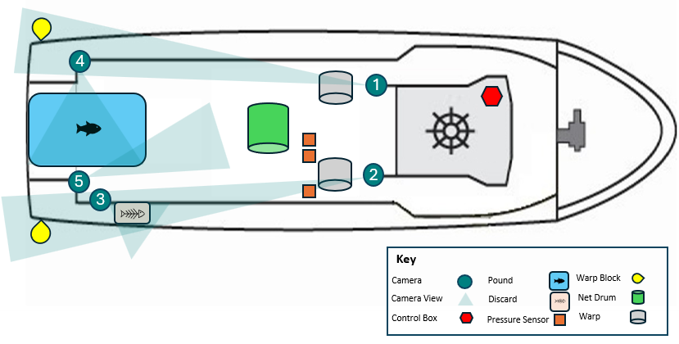
Comments:

Camera specifications and range of view are displayed below.
Camera No. | C1 | Camera Install Location
Area Covered  (Refer to Fishery Specific Requirements in Annex 1) |  | Insert Image  All personal and commercial sensitive information must be removed from images. This includes, but is not limited to, people’s faces, timestamps, vessel positions, logos, and/or proprietary fishing gear.
Action Covered
(Refer to Fishery Specific Requirements in Annex 1)
Minimum Data Requirement Recorded
(Refer to Fishery Specific Requirements in Annex 1)
Camera Make and Model
Frame Per Second
Resolution |  | Camera View
Trigger Settings |  | Insert Image  All personal and commercial sensitive information must be removed from images. This includes, but is not limited to, people’s faces, timestamps, vessel positions, logos, and/or proprietary fishing gear.
Recording Exceptions
Run on Time
Weather Resistance

Camera No. | C2 | Camera Install Location
Area Covered  (Refer to Fishery Specific Requirements in Annex 1) |  | Insert Image  All personal and commercial sensitive information must be removed from images. This includes, but is not limited to, people’s faces, timestamps, vessel positions, logos, and/or proprietary fishing gear.
Action Covered
(Refer to Fishery Specific Requirements in Annex 1)
Minimum Data Requirement Recorded
(Refer to Fishery Specific Requirements in Annex 1)
Camera Make and Model
Frame Per Second
Resolution |  | Camera View
Trigger Settings |  | Insert Image  All personal and commercial sensitive information must be removed from images. This includes, but is not limited to, people’s faces, timestamps, vessel positions, logos, and/or proprietary fishing gear.
Recording Exceptions
Run on Time
Weather Resistance

Camera No. | C3 | Camera Install Location
Area Covered  (Refer to Fishery Specific Requirements in Annex 1) |  | Insert Image  All personal and commercial sensitive information must be removed from images. This includes, but is not limited to, people’s faces, timestamps, vessel positions, logos, and/or proprietary fishing gear.
Action Covered
(Refer to Fishery Specific Requirements in Annex 1)
Minimum Data Requirement Recorded
(Refer to Fishery Specific Requirements in Annex 1)
Camera Make and Model
Frame Per Second
Resolution |  | Camera View
Trigger Settings |  | Insert Image  All personal and commercial sensitive information must be removed from images. This includes, but is not limited to, people’s faces, timestamps, vessel positions, logos, and/or proprietary fishing gear.
Recording Exceptions
Run on Time
Weather Resistance

Camera No. | C4 | Camera Install Location
Area Covered  (Refer to Fishery Specific Requirements in Annex 1) |  | Insert Image  All personal and commercial sensitive information must be removed from images. This includes, but is not limited to, people’s faces, timestamps, vessel positions, logos, and/or proprietary fishing gear.
Action Covered
(Refer to Fishery Specific Requirements in Annex 1)
Minimum Data Requirement Recorded
(Refer to Fishery Specific Requirements in Annex 1)
Camera Make and Model
Frame Per Second
Resolution |  | Camera View
Trigger Settings |  | Insert Image  All personal and commercial sensitive information must be removed from images. This includes, but is not limited to, people’s faces, timestamps, vessel positions, logos, and/or proprietary fishing gear.
Recording Exceptions
Run on Time
Weather Resistance

Camera No. | C5 | Camera Install Location
Area Covered  (Refer to Fishery Specific Requirements in Annex 1) |  | Insert Image  All personal and commercial sensitive information must be removed from images. This includes, but is not limited to, people’s faces, timestamps, vessel positions, logos, and/or proprietary fishing gear.
Action Covered
(Refer to Fishery Specific Requirements in Annex 1)
Minimum Data Requirement Recorded
(Refer to Fishery Specific Requirements in Annex 1)
Camera Make and Model
Frame Per Second
Resolution |  | Camera View
Trigger Settings |  | Insert Image  All personal and commercial sensitive information must be removed from images. This includes, but is not limited to, people’s faces, timestamps, vessel positions, logos, and/or proprietary fishing gear.
Recording Exceptions
Run on Time
Weather Resistance

Have the cameras been positioned to allow crew to safely clean while the vessel is at sea?
Yes No (Tick one box)

Have the cameras been positioned to minimise the accumulation of sea salt or water drops on the lens?
Yes No (Tick one box)

Have the cameras been positioned to minimise the effects from glare from deck lights at night and/or reflected light?
Yes No (Tick one box)

Have the cameras been positioned to minimise obstruction of the camera’s view by gear or crew during fishing activities?
Yes No (Tick one box)

Installation of Other System Components
The following system parts below have been installed on the vessel.
Add or remove installed items as applicable.

Installed Item | Location | Specification | Details
Control Centre | Insert Image of installed Item  All personal and commercial sensitive information must be removed from images. This includes, but is not limited to, people’s faces, timestamps, vessel positions, logos, and/or proprietary fishing gear. | Install location
Control Centre |  | Manufacturer
Control Centre |  | Make and model
Control Centre |  | Function
Control Centre |  | Capacity
Control Centre |  | Recording time
Control Centre |  | Redundant power supply
Control Centre |  | Security and protection
Control Centre |  | Software version
Control Centre |  | Operating system
Control Centre |  | Video compression
Satellite Modem | Insert Image of installed Item  All personal and commercial sensitive information must be removed from images. This includes, but is not limited to, people’s faces, timestamps, vessel positions, logos, and/or proprietary fishing gear. | Install location
Satellite Modem |  | Function
Satellite Modem |  | Water resistance
GPS  Receiver | Insert Image of installed Item  All personal and commercial sensitive information must be removed from images. This includes, but is not limited to, people’s faces, timestamps, vessel positions, logos, and/or proprietary fishing gear. | Install location
GPS  Receiver |  | Function
GPS  Receiver |  | Records
GPS  Receiver |  | Water resistance
POE Switch | Insert Image of installed Item  All personal and commercial sensitive information must be removed from images. This includes, but is not limited to, people’s faces, timestamps, vessel positions, logos, and/or proprietary fishing gear. | Install location
POE Switch |  | Function
Sensor(s) | Insert Image of installed Item  All personal and commercial sensitive information must be removed from images. This includes, but is not limited to, people’s faces, timestamps, vessel positions, logos, and/or proprietary fishing gear. | Install location
Sensor(s) |  | Function
Sensor(s) |  | Units
Sensor(s) |  | Threshold Values
Sensor(s) |  | Data recording frequencies
Monitor | Insert Image of installed Item  All personal and commercial sensitive information must be removed from images. This includes, but is not limited to, people’s faces, timestamps, vessel positions, logos, and/or proprietary fishing gear. | Install location
Monitor |  | Function
Keyboard | Insert Image of installed Item  All personal and commercial sensitive information must be removed from images. This includes, but is not limited to, people’s faces, timestamps, vessel positions, logos, and/or proprietary fishing gear. | Install location
Keyboard |  | Function

Radio Frequency Interference
Following installation, the radio frequencies emitted by the e-monitoring system were tested to determine if they interfered with the vessel’s safety and navigational equipment on ___ /___ /___ at __________.
Has the e-monitoring system shown to be capable of functioning in close physical proximity to other onboard electrical and hydraulic equipment and not impact (e.g. through radio frequency interference) the proper functioning of other onboard safety and navigational equipment on the vessel?
Yes No (Tick one box)

Section 3. Installation Declaration (E-monitoring service provider representative and the Concession Holder must complete and sign Section 3 before submitting to AFMA)

E-monitoring Service Provider
On behalf of ______________, I hereby declare that an AFMA type approved e--monitoring system was successfully installed on this fishing vessel on ___ /___ /___ at ___________ port location and that all system components are installed and configured in accordance with Section 2 above.

____________________________________________
Business Name

____________________________________________
Representative Name

____________________________________________
Signature & Date

Vessel Representative
I ____________, hereby declare that the details in Section 1 and 2 of this VMP are true and accurate to the best of my knowledge.
I understand I may be required to modify e-monitoring system components to enable the collection of minimum data requirements for the fishery.
I understand that any changes to this VMP will need to be communicated and submitted to AFMA immediately or I may be deemed as not compliant with fishing with an operational e-monitoring system.

____________________________________________
Business Name

____________________________________________
Concession Holder Name

____________________________________________
Signature & Date

FOR AFMA USE ONLY

Section 4. Data Completeness (AFMA representative must complete and sign Section 4 to confirm the e-monitoring system has met AFMAs Requirements)

Encryption & Decryption
Was AFMA able to successfully decrypt e-monitoring information using the decryption keys supplied by the e-monitoring service provider?
Yes No (Tick one box)
Comment:

Data Review
Were all e-monitoring records recorded by the system and stored on the external data drive?
Yes No (Tick one box)
Comment:

Was AFMA able to ingest and review all e-monitoring records into AFMAs review software?
Yes No (Tick one box)
Comment:
[Insert image(s) of data ingested into Tator for completeness]

Was AFMA able to review the information on the e-monitoring records to collect minimum data requirements for the fishery?
Yes No (Tick one box)
Comment:
[Refer to minimum data requirements in Annex1]

Near Real Time
Did the e-monitoring system record and transmit all near real time records to AFMA?
Yes No (Tick one box)
Comment:

Was near real time information transmitted to AFMA on an hourly basis while the vessel was out at sea?
Yes No (Tick one box)
Comment:
[Insert image of near real time records in AFMA database and/or trackwell]

Modifications
Are modifications required?
Yes No (Tick one box)
If yes, modifications include:

Australian Fisheries Management Authority

I ___________, have undertaken a data completeness testing and believe that the type-approved e-monitoring system has been installed and configured to meet AFMAs Fishery Specific Requirements for the Great Australian Bight Trawl Sector of the Southern and Eastern Scalefish and Shark Fishery E-monitoring Program.

____________________________________________
AFMA Representative Name

____________________________________________
Position Title

____________________________________________
Signature & Date

Annex 1. Fishery Specific Requirements for Great Australian Bight Trawl in the Southern and Eastern Scalefish and Shark Fishery
AFMA type-approved e-monitoring systems used in the Great Australian Bight (GAB) Trawl Sector of the Southern and Eastern Scalefish and Shark Fishery must use cameras to record the occurrence of fishing events, all catch interactions, including interactions with endangered, threatened and protected (ETP) species, and the use of mitigation device(s).
The e-monitoring system must be configured to cover and collect the following areas, actions and minimum data requirements on GAB trawl vessels:
Areas Covered
Areas that cameras are required to cover include:
- area(s) where mitigation devices are used to prevent seabird interactions with warp wires (usually both port and sideboard of the vessel),
- working deck where catch is handled and processed (pound),
- all areas used to discard bycatch (port and starboard scuppers), and
- an area dedicated to fish length measurements.
Actions Covered
Actions that cameras are required to cover include:
- use of mitigation devices (e.g., bird bafflers, Seal Excluder Devices),
- deployment and retrieval of fishing gear,
- all netted catch species (both retained and discarded),
- the fate of the catch and bycatch life status,
- any interactions with ETP species, and
- fish length measurements.
Minimum Data Requirements
Within these areas and actions covered, the minimum data requirements to be collected on GAB trawl vessels are outlined in Table 1.
Table 1. General areas/activities monitored by onboard cameras to meet minimum data requirements for otter board trawl Great Australian Bight Trawl Sector vessels.
Area Covered | Action Covered | Minimum data requirements to be captured for video review
Port and starboard warp wires | ETP species interactions during gear setting and retrieval, mitigation deployment | Position, date, and time
Port and starboard warp wires |  | Species (lowest taxonomic group)
Port and starboard warp wires |  | Number
Port and starboard warp wires |  | Fate
Port and starboard warp wires |  | Life status
Port and starboard warp wires |  | Mitigation device
Port and starboard discard scuppers | ETP species interactions during sort, opportunity for close-up species identification | Position, date, and time
Port and starboard discard scuppers |  | Species (lowest taxonomic group)
Port and starboard discard scuppers |  | Number/proportions/weight
Port and starboard discard scuppers |  | Fate
Port and starboard discard scuppers |  | Life status
Main deck (pound) | All catch items (target species, bycatch and ETP species) | Position, date, and time
Main deck (pound) | All catch items (target species, bycatch and ETP species) | Species composition (lowest taxonomic group)
Main deck (pound) | All catch items (target species, bycatch and ETP species) | Number/proportions/weight
Main deck (pound) | All catch items (target species, bycatch and ETP species) | Fate (retained/discarded)
Fish length measuring area | Catch measurement | Position, date, and time
Fish length measuring area | Catch measurement | Species
Fish length measuring area | Catch measurement | Length (nearest cm)

On most GAB trawl vessels, two cameras are placed to record the deployment and retrieval of fishing gear (one on the port and one on the starboard side of the vessel), a third and fourth camera is positioned to record discard areas (one on the port and one on the starboard side of the vessel), a fifth camera is positioned over the main deck (pound) where the catch is spilled and sorted, and a sixth camera is positioned over the area dedicated to fish length measuring. An example of possible camera placement(s) to meet minimum data requirements for trawl vessels is shown in Figure 1 for guidance.
Figure 1. E-monitoring system install plan for otter trawl in the Great Australian Bight Trawl Sector.
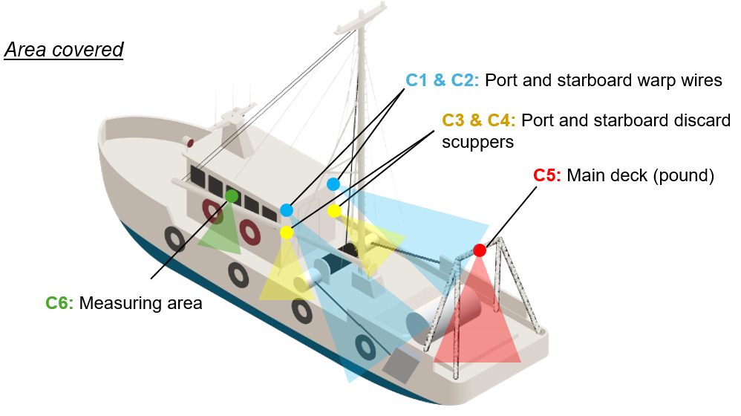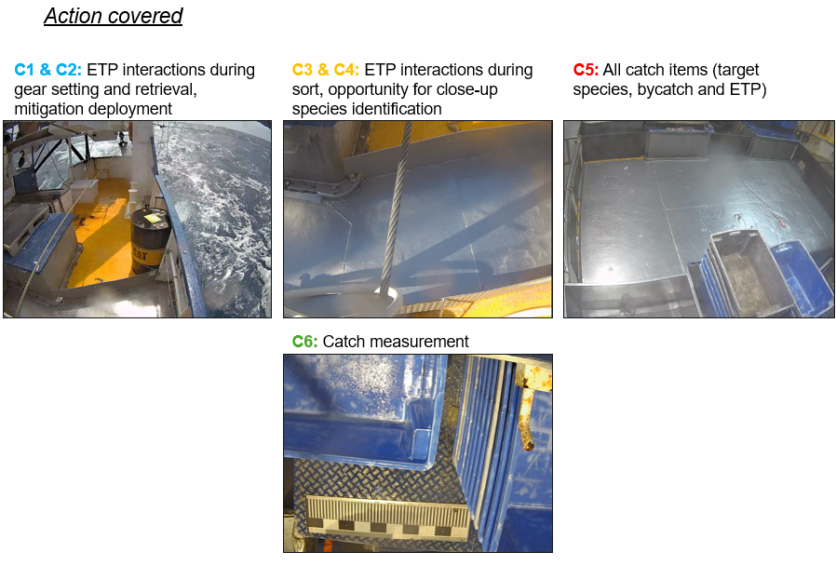

The e-monitoring system must incorporate sensors to monitor gear activity and collect fish length data, and automatically trigger camera recording at the start and end of setting and hauling operations (also referred to as a “shot”), as well as during catch sorting. For otter board trawl vessels, the start of a set is defined as the point at which the otter boards are deployed from the vessel, and the end of the haul is when the otter boards are retrieved onboard.
To ensure adequate monitoring of catch sorting, the system must be configured with a run-on recording time of 60 minutes following sensor activation. When targeting orange roughy or blue grenadier, this run-on time must be extended to 120 minutes to ensure full coverage of sorting activities. Where catch is processed using a conveyor belt, sensors must trigger camera recording for the full duration of conveyor belt operation.
When fish length measurements are undertaken, the system must be configured to record for 30 minutes following activation of a manual trigger (button) linked to the camera positioned over the designated fish measurement area.

