
Vessel Monitoring Plan

[Insert Vessel Name]

Securing Australia’s fishing future
www.afma.gov.au
Securing Australia’s fishing future
www.afma.gov.au
Contents
Section 1. Concession Holder and Vessel Information (Concession holder must complete Section 1 before submitting to AFMA) 3
Section 2. E-monitoring System Installation (E-monitoring service provider representative and/or the Concession Holder are to complete Section 2 before submitting to AFMA) 4
Section 3. Installation Declaration (E-monitoring service provider representative and the Concession Holder must complete and sign Section 3 before submitting it to AFMA) 11
Section 4. Data Completeness (AFMA representative must complete and sign Section 4 to confirm the e-monitoring system has met AFMAs Requirements) 13
Annex 1. Fishery Specific Requirements for the North West Slope Tawl and Western Deepwater Trawl Fisheries 15

A Vessel Monitoring Plan (VMP) is a document prepared by the Concession Holder and their chosen electronic monitoring (e‑monitoring) service provider that describes the vessel’s e‑monitoring system, including its equipment specifications, installation and configuration, and demonstrates how the system records the fishing activities required for the relevant fishery.
The purpose of the VMP is to enable AFMA to confirm that a type-approved e-monitoring system is used and that it has been installed and configured to meet AFMA’s fishery-specific requirements (refer to Annex 1).
If AFMA determines that the installation or configuration of the e-monitoring system has not met AFMA’s requirements, the Concession Holder may be required to take corrective action. This may include revising the VMP, adjusting the installation or configuration of the e-monitoring system, and providing an updated VMP form to AFMA. AFMA may also require additional information to demonstrate that any identified issues have been addressed before the e-monitoring system is considered suitable for ongoing use.

Section 1. Concession Holder and Vessel Information (Concession holder must complete Section 1 before submitting to AFMA)

Concession Holder
Business Name
Full Name
Phone
Mobile
Email

Vessel Details
Vessel Name
Vessel Call Sign
International Maritime Organisation (IMO) number
Homeport
Vessel Length Overall (LOA)
Gross Tonnage
Target Fishery
Fishing Method Used

Section 2. E-monitoring System Installation
(E-monitoring service provider representative and/or the Concession Holder are to complete Section 2 before submitting to AFMA)

E-monitoring Service Provider Details
E-monitoring Service Provider Business
Services Provided
Office Location
Phone
Email

Camera Installation Overview
The installed camera positions and their range of views are as displayed on the vessel image below.
IMPORTANT NOTE: The number and position of cameras installed on the vessel MUST cover areas, actions and minimum data requirements outlined in the Fishery Specific Requirements (refer to Annex 1).
The below camera position and range of view diagram is an example for a trawl vessel as guidance. Please insert the vessel specific outlay of each camera installed on a vessel within a diagram below. If required, AFMA can provide a diagram template upon request.

.

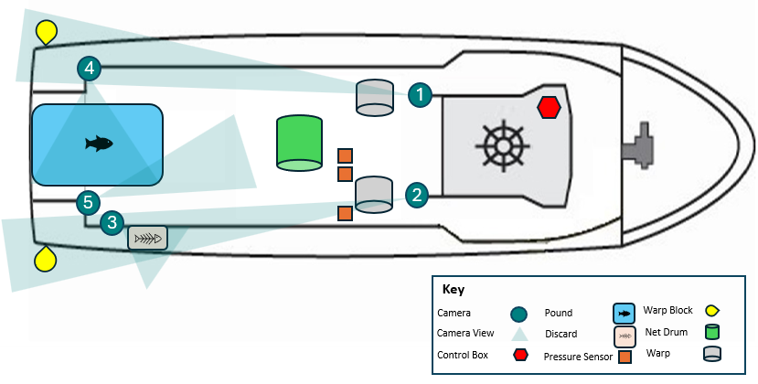
Comments:

Camera specifications and range of view are displayed below.
Camera No. | C1 | Camera Install Location
Area Covered  (Refer to Fishery Specific Requirements in Annex 1) |  | Insert Image  All personal and commercial sensitive information must be removed from images. This includes, but is not limited to, people’s faces, timestamps, vessel positions, logos, and/or proprietary fishing gear.
Action Covered
(Refer to Fishery Specific Requirements in Annex 1)
Minimum Data Requirement Recorded
(Refer to Fishery Specific Requirements in Annex 1)
Camera Make and Model
Frame Per Second
Resolution |  | Camera View
Trigger Settings |  | Insert Image  All personal and commercial sensitive information must be removed from images. This includes, but is not limited to, people’s faces, timestamps, vessel positions, logos, and/or proprietary fishing gear.
Recording Exceptions
Run on Time
Weather Resistance

Camera No. | C2 | Camera Install Location
Area Covered  (Refer to Fishery Specific Requirements in Annex 1) |  | Insert Image  All personal and commercial sensitive information must be removed from images. This includes, but is not limited to, people’s faces, timestamps, vessel positions, logos, and/or proprietary fishing gear.
Action Covered
(Refer to Fishery Specific Requirements in Annex 1)
Minimum Data Requirement Recorded
(Refer to Fishery Specific Requirements in Annex 1)
Camera Make and Model
Frame Per Second
Resolution |  | Camera View
Trigger Settings |  | Insert Image  All personal and commercial sensitive information must be removed from images. This includes, but is not limited to, people’s faces, timestamps, vessel positions, logos, and/or proprietary fishing gear.
Recording Exceptions
Run on Time
Weather Resistance

Camera No. | C3 | Camera Install Location
Area Covered  (Refer to Fishery Specific Requirements in Annex 1) |  | Insert Image  All personal and commercial sensitive information must be removed from images. This includes, but is not limited to, people’s faces, timestamps, vessel positions, logos, and/or proprietary fishing gear.
Action Covered
(Refer to Fishery Specific Requirements in Annex 1)
Minimum Data Requirement Recorded
(Refer to Fishery Specific Requirements in Annex 1)
Camera Make and Model
Frame Per Second
Resolution |  | Camera View
Trigger Settings |  | Insert Image  All personal and commercial sensitive information must be removed from images. This includes, but is not limited to, people’s faces, timestamps, vessel positions, logos, and/or proprietary fishing gear.
Recording Exceptions
Run on Time
Weather Resistance

Camera No. | C4 | Camera Install Location
Area Covered  (Refer to Fishery Specific Requirements in Annex 1) |  | Insert Image  All personal and commercial sensitive information must be removed from images. This includes, but is not limited to, people’s faces, timestamps, vessel positions, logos, and/or proprietary fishing gear.
Action Covered
(Refer to Fishery Specific Requirements in Annex 1)
Minimum Data Requirement Recorded
(Refer to Fishery Specific Requirements in Annex 1)
Camera Make and Model
Frame Per Second
Resolution |  | Camera View
Trigger Settings |  | Insert Image  All personal and commercial sensitive information must be removed from images. This includes, but is not limited to, people’s faces, timestamps, vessel positions, logos, and/or proprietary fishing gear.
Recording Exceptions
Run on Time
Weather Resistance

Camera No. | C5 | Camera Install Location
Area Covered  (Refer to Fishery Specific Requirements in Annex 1) |  | Insert Image  All personal and commercial sensitive information must be removed from images. This includes, but is not limited to, people’s faces, timestamps, vessel positions, logos, and/or proprietary fishing gear.
Action Covered
(Refer to Fishery Specific Requirements in Annex 1)
Minimum Data Requirement Recorded
(Refer to Fishery Specific Requirements in Annex 1)
Camera Make and Model
Frame Per Second
Resolution |  | Camera View
Trigger Settings |  | Insert Image  All personal and commercial sensitive information must be removed from images. This includes, but is not limited to, people’s faces, timestamps, vessel positions, logos, and/or proprietary fishing gear.
Recording Exceptions
Run on Time
Weather Resistance

Have the cameras been positioned to allow crew to safely clean while the vessel is at sea?
Yes No (Tick one box)

Have the cameras been positioned to minimise the accumulation of sea salt or water drops on the lens?
Yes No (Tick one box)

Have the cameras been positioned to minimise the effects from glare from deck lights at night and/or reflected light?
Yes No (Tick one box)

Have the cameras been positioned to minimise obstruction of the camera’s view by gear or crew during fishing activities?
Yes No (Tick one box)

Installation of Other System Components
The following system parts below have been installed on the vessel.
Add or remove installed items as applicable.

Installed Item | Location | Specification | Details
Control Centre | Insert Image of installed Item  All personal and commercial sensitive information must be removed from images. This includes, but is not limited to, people’s faces, timestamps, vessel positions, logos, and/or proprietary fishing gear. | Install location
Control Centre |  | Manufacturer
Control Centre |  | Make and model
Control Centre |  | Function
Control Centre |  | Capacity
Control Centre |  | Recording time
Control Centre |  | Redundant power supply
Control Centre |  | Security and protection
Control Centre |  | Software version
Control Centre |  | Operating system
Control Centre |  | Video compression
Satellite Modem | Insert Image of installed Item  All personal and commercial sensitive information must be removed from images. This includes, but is not limited to, people’s faces, timestamps, vessel positions, logos, and/or proprietary fishing gear. | Install location
Satellite Modem |  | Function
Satellite Modem |  | Water resistance
GPS  Receiver | Insert Image of installed Item  All personal and commercial sensitive information must be removed from images. This includes, but is not limited to, people’s faces, timestamps, vessel positions, logos, and/or proprietary fishing gear. | Install location
GPS  Receiver |  | Function
GPS  Receiver |  | Records
GPS  Receiver |  | Water resistance
POE Switch | Insert Image of installed Item  All personal and commercial sensitive information must be removed from images. This includes, but is not limited to, people’s faces, timestamps, vessel positions, logos, and/or proprietary fishing gear. | Install location
POE Switch |  | Function
Sensor(s) | Insert Image of installed Item  All personal and commercial sensitive information must be removed from images. This includes, but is not limited to, people’s faces, timestamps, vessel positions, logos, and/or proprietary fishing gear. | Install location
Sensor(s) |  | Function
Sensor(s) |  | Units
Sensor(s) |  | Threshold Values
Sensor(s) |  | Data recording frequencies
Monitor | Insert Image of installed Item  All personal and commercial sensitive information must be removed from images. This includes, but is not limited to, people’s faces, timestamps, vessel positions, logos, and/or proprietary fishing gear. | Install location
Monitor |  | Function
Keyboard | Insert Image of installed Item  All personal and commercial sensitive information must be removed from images. This includes, but is not limited to, people’s faces, timestamps, vessel positions, logos, and/or proprietary fishing gear. | Install location
Keyboard |  | Function

Radio Frequency Interference
Following installation, the radio frequencies emitted by the e-monitoring system were tested to determine if they interfered with the vessel’s safety and navigational equipment on ___ /___ /___ at __________.
Has the e-monitoring system shown to be capable of functioning in close physical proximity to other onboard electrical and hydraulic equipment and not impact (e.g. through radio frequency interference) the proper functioning of other onboard safety and navigational equipment on the vessel?
Yes No (Tick one box)

Section 3. Installation Declaration (E-monitoring service provider representative and the Concession Holder must complete and sign Section 3 before submitting it to AFMA)

E-monitoring Service Provider
On behalf of ______________, I hereby declare that an AFMA type approved e--monitoring system was successfully installed on this fishing vessel on ___ /___ /___ at ___________ port location and that all system components are installed and configured in accordance with Section 2 above.

____________________________________________
Business Name

____________________________________________
Representative Name

____________________________________________
Signature & Date

Vessel Representative
I ____________, hereby declare that the details in Section 1 and 2 of this VMP are true and accurate to the best of my knowledge.
I understand I may be required to modify e-monitoring system components to enable the collection of minimum data requirements for the fishery.
I understand that any changes to this VMP will need to be communicated and submitted to AFMA immediately or I may be deemed as not compliant with fishing with an operational e-monitoring system.

____________________________________________
Business Name

____________________________________________
Concession Holder Name

____________________________________________
Signature & Date

FOR AFMA USE ONLY

Section 4. Data Completeness (AFMA representative must complete and sign Section 4 to confirm the e-monitoring system has met AFMAs Requirements)

Encryption & Decryption
Was AFMA able to successfully decrypt e-monitoring information using the decryption keys supplied by the e-monitoring service provider?
Yes No (Tick one box)

Comment:

Data Review
Were all e-monitoring records recorded by the system and stored on the external data drive?
Yes No (Tick one box)
Comment:

Was AFMA able to ingest and review all e-monitoring records into AFMAs review software?
Yes No (Tick one box)
Comment:
[Insert image(s) of data ingested into Tator for completeness]

Was AFMA able to review the information on the e-monitoring records to collect minimum data requirements for the fishery?
Yes No (Tick one box)
Comment:
[Refer to minimum data requirements in Annex1]

Near Real Time
Did the e-monitoring system record and transmit all near real time records to AFMA?
Yes No (Tick one box)
Comment:

Was near real time information transmitted to AFMA on an hourly basis while the vessel was out at sea?
Yes No (Tick one box)

Comment:
[Insert image of near real time records ingested into the AFMA database and/or trackwell]

Modifications
Are modifications required?
Yes No (Tick one box)
If yes, modifications include:

Australian Fisheries Management Authority

I ___________, have undertaken a data completeness testing and believe that the type-approved e-monitoring system has been installed and configured to meet AFMAs Fishery Specific Requirements for the North West Slope Trawl Fishery and Western Deepwater Trawl Fishery E-monitoring Program.

____________________________________________
AFMA Representative Name

____________________________________________
Position Title

____________________________________________
Signature & Date

Annex 1. Fishery Specific Requirements for the North West Slope Tawl and Western Deepwater Trawl Fisheries
AFMA type-approved e-monitoring systems used in the North West Slope Trawl Fishery and the Western Deepwater Trawl Fishery (known collectively as the Western Trawl Fisheries) must use cameras to record the occurrence of fishing events, all catch interactions, including interactions with ETP species, and the use of mitigation device(s).
The e-monitoring system cameras must be configured to cover and collect the following areas, actions and minimum data requirements on Western Trawl Fisheries vessels:
Areas Covered
Areas that cameras are required to cover include:
- area where the trawl gear is set and hauled,
- hopper where the catch is spilled from the nets,
- conveyor where the catch is sorted, and
- processing area where the catch is stored.
Actions Covered
Actions that cameras are required to cover include:
- deployment and retrieval of fishing gear,
- all netted catch species (both retained and discarded),
- the fate and life status of bycatch byproduct species of interest, and
- any interactions with ETP species.
Minimum Data Requirements
Within these areas and actions covered, the minimum data requirements to be collected on prawn trawl vessels are outlined in Table 1.
Table 1. General areas/activities monitored by onboard cameras to meet minimum data requirements for Western Trawl Fisheries vessels.
Area Covered | Action Covered | Minimum data requirements to be captured for video review
Stern | ETP species interactions and drop-outs when cod-ends lifted from water | Position, date, and time
Stern |  | Species (lowest taxonomic group)
Stern |  | Number
Stern |  | Fate
Stern |  | Life status
Stern | Hauling operation | Start/end position, date, and time
Sorting conveyor | ETP species interactions during sort, opportunity for close-up species identification | Position, date, and time
Sorting conveyor |  | Species (lowest taxonomic group)
Sorting conveyor |  | Number
Sorting conveyor |  | Fate
Sorting conveyor |  | Life status
Hopper | ETP species interactions in spill | Position, date, and time
Hopper | ETP species interactions in spill | Species (lowest taxonomic group)
Hopper | ETP species interactions in spill | Number
Hopper | ETP species interactions in spill | Fate
Hopper | ETP species interactions in spill | Life status
Processing area | Retention of species of interest | Position, date, and time
Processing area | Retention of species of interest | Species (lowest taxonomic group)
Processing area | Retention of species of interest | Number
Processing area | Retention of species of interest | Fate
Processing area | Retention of species of interest | Life status

On most Western Trawl Fisheries vessels, an aft facing camera is positioned to record the setting and hauling of the gear, interactions in the throat of the net, and dropouts when the cod-end is lifted from the water, a second camera is positioned over the hopper to record ETP species interactions when the nets are spilled, a third camera is positioned directly over the conveyor to identify ETP species during the sort, and a fourth camera is positioned to record the processing area where the catch is stored. An example of possible camera placement(s) to meet minimum data requirements for Western Trawl Fisheries vessels is shown in Figure 1 for guidance.
Figure 1. E-monitoring system install plan for the Western Trawl Fisheries. 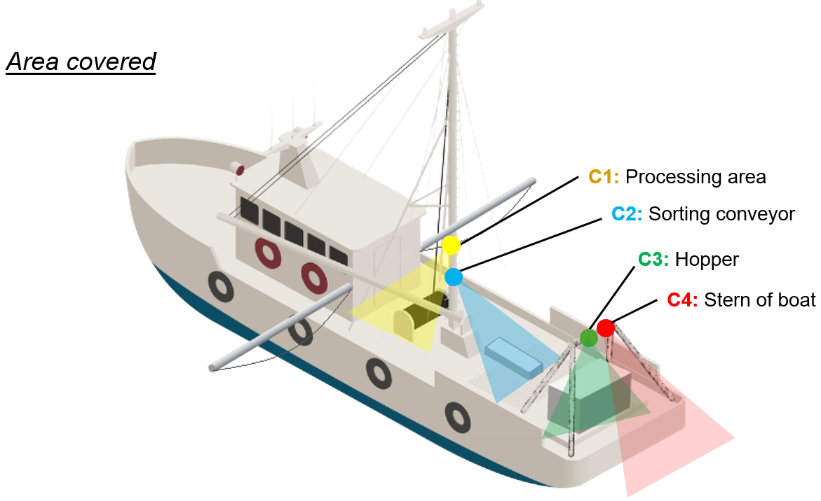
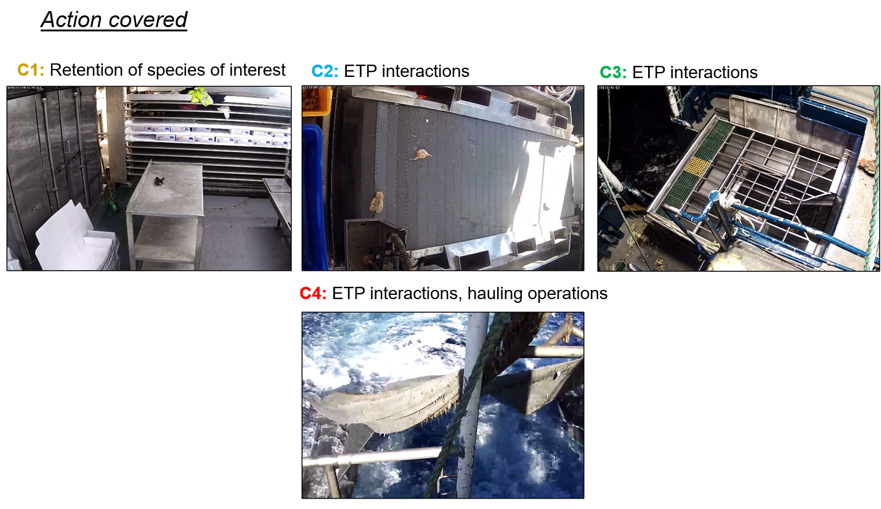

The e-monitoring system must incorporate sensors to monitor gear activity and automatically trigger camera recording at the start and end of setting and hauling operations (also referred to as a “shot”), as well as during catch sorting. For Western Trawl Fishery vessels, the start of a shot (set) is when the otter boards have been deployed from the vessel, the end of the shot (haul) is when the boards are brought back onboard.
To ensure adequate monitoring of catch sorting, the system must be configured with a run-on recording time of 60 minutes following sensor activation.

