
Vessel Monitoring Plan

[Insert Vessel Name]

Securing Australia’s fishing future
www.afma.gov.au
Securing Australia’s fishing future
www.afma.gov.au
Contents
Section 1. Concession Holder and Vessel Information (Concession holder must complete Section 1 before submitting to AFMA) 3
Section 2. E-monitoring System Installation (E-monitoring service provider representative and/or the Concession Holder are to complete Section 2 before submitting to AFMA) 4
Section 3. Installation Declaration (E-monitoring service provider representative and the Concession Holder must complete and sign Section 3 before submitting it to AFMA) 11
Section 4. Data Completeness (AFMA representative must complete and sign Section 5 to confirm the e-monitoring system has met AFMAs Requirements) 12
Annex 1. Fishery Specific Requirements for Midwater Trawl in the Small Pelagic Fishery 15

A Vessel Monitoring Plan (VMP) is a document prepared by the Concession Holder and their chosen electronic monitoring (e‑monitoring) service provider that describes the vessel’s e‑monitoring system, including its equipment specifications, installation and configuration, and demonstrates how the system records the fishing activities required for the relevant fishery.
The purpose of the VMP is to enable AFMA to confirm that a type-approved e-monitoring system is used and that it has been installed and configured to meet AFMA’s fishery-specific requirements (refer to Annex 1).
If AFMA determines that the installation or configuration of the e-monitoring system has not met AFMA’s requirements, the Concession Holder may be required to take corrective action. This may include revising the VMP, adjusting the installation or configuration of the e-monitoring system, and providing an updated VMP form to AFMA. AFMA may also require additional information to demonstrate that any identified issues have been addressed before the e-monitoring system is considered suitable for ongoing use.

Section 1. Concession Holder and Vessel Information (Concession holder must complete Section 1 before submitting to AFMA)

Concession Holder
Business Name
Full Name
Phone
Mobile
Email

Vessel Details
Vessel Name
Vessel Call Sign
International Maritime Organisation (IMO) number
Homeport
Vessel Length Overall (LOA)
Gross Tonnage
Target Fishery
Fishing Method Used

Section 2. E-monitoring System Installation
(E-monitoring service provider representative and/or the Concession Holder are to complete Section 2 before submitting to AFMA)

E-monitoring Service Provider Details
E-monitoring Service Provider Business
Services Provided
Office Location
Phone
Email

Camera Installation Overview
The installed camera positions and their range of views are as displayed on the vessel image below.
IMPORTANT NOTE: The number and position of cameras installed on the vessel MUST cover areas, actions and minimum data requirements outlined in the Fishery Specific Requirements (refer to Annex 1).
The below camera position and range of view diagram is an example for a trawl vessel as guidance. Please insert the vessel specific outlay of each camera installed on a vessel within a diagram below. If required, AFMA can provide a diagram template upon request.

.

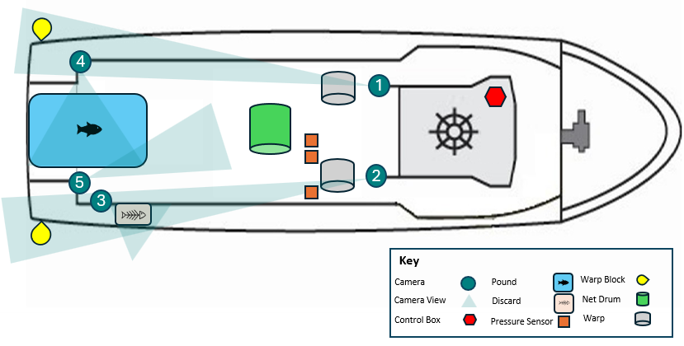
Comments:

Camera specifications and range of view are displayed below.
Camera No. | C1 | Camera Install Location
Area Covered  (Refer to Fishery Specific Requirements in Annex 1) |  | Insert Image  All personal and commercial sensitive information must be removed from images. This includes, but is not limited to, people’s faces, timestamps, vessel positions, logos, and/or proprietary fishing gear.
Action Covered
(Refer to Fishery Specific Requirements in Annex 1)
Minimum Data Requirement Recorded
(Refer to Fishery Specific Requirements in Annex 1)
Camera Make and Model
Frame Per Second
Resolution |  | Camera View
Trigger Settings |  | Insert Image  All personal and commercial sensitive information must be removed from images. This includes, but is not limited to, people’s faces, timestamps, vessel positions, logos, and/or proprietary fishing gear.
Recording Exceptions
Run on Time
Weather Resistance

Camera No. | C2 | Camera Install Location
Area Covered  (Refer to Fishery Specific Requirements in Annex 1) |  | Insert Image  All personal and commercial sensitive information must be removed from images. This includes, but is not limited to, people’s faces, timestamps, vessel positions, logos, and/or proprietary fishing gear.
Action Covered
(Refer to Fishery Specific Requirements in Annex 1)
Minimum Data Requirement Recorded
(Refer to Fishery Specific Requirements in Annex 1)
Camera Make and Model
Frame Per Second
Resolution |  | Camera View
Trigger Settings |  | Insert Image  All personal and commercial sensitive information must be removed from images. This includes, but is not limited to, people’s faces, timestamps, vessel positions, logos, and/or proprietary fishing gear.
Recording Exceptions
Run on Time
Weather Resistance

Camera No. | C3 | Camera Install Location
Area Covered  (Refer to Fishery Specific Requirements in Annex 1) |  | Insert Image  All personal and commercial sensitive information must be removed from images. This includes, but is not limited to, people’s faces, timestamps, vessel positions, logos, and/or proprietary fishing gear.
Action Covered
(Refer to Fishery Specific Requirements in Annex 1)
Minimum Data Requirement Recorded
(Refer to Fishery Specific Requirements in Annex 1)
Camera Make and Model
Frame Per Second
Resolution |  | Camera View
Trigger Settings |  | Insert Image  All personal and commercial sensitive information must be removed from images. This includes, but is not limited to, people’s faces, timestamps, vessel positions, logos, and/or proprietary fishing gear.
Recording Exceptions
Run on Time
Weather Resistance

Camera No. | C4 | Camera Install Location
Area Covered  (Refer to Fishery Specific Requirements in Annex 1) |  | Insert Image  All personal and commercial sensitive information must be removed from images. This includes, but is not limited to, people’s faces, timestamps, vessel positions, logos, and/or proprietary fishing gear.
Action Covered
(Refer to Fishery Specific Requirements in Annex 1)
Minimum Data Requirement Recorded
(Refer to Fishery Specific Requirements in Annex 1)
Camera Make and Model
Frame Per Second
Resolution |  | Camera View
Trigger Settings |  | Insert Image  All personal and commercial sensitive information must be removed from images. This includes, but is not limited to, people’s faces, timestamps, vessel positions, logos, and/or proprietary fishing gear.
Recording Exceptions
Run on Time
Weather Resistance

Camera No. | C5 | Camera Install Location
Area Covered  (Refer to Fishery Specific Requirements in Annex 1) |  | Insert Image  All personal and commercial sensitive information must be removed from images. This includes, but is not limited to, people’s faces, timestamps, vessel positions, logos, and/or proprietary fishing gear.
Action Covered
(Refer to Fishery Specific Requirements in Annex 1)
Minimum Data Requirement Recorded
(Refer to Fishery Specific Requirements in Annex 1)
Camera Make and Model
Frame Per Second
Resolution |  | Camera View
Trigger Settings |  | Insert Image  All personal and commercial sensitive information must be removed from images. This includes, but is not limited to, people’s faces, timestamps, vessel positions, logos, and/or proprietary fishing gear.
Recording Exceptions
Run on Time
Weather Resistance

Have the cameras been positioned to allow crew to safely clean while the vessel is at sea?
Yes No (Tick one box)

Have the cameras been positioned to minimise the accumulation of sea salt or water drops on the lens?
Yes No (Tick one box)

Have the cameras been positioned to minimise the effects from glare from deck lights at night and/or reflected light?
Yes No (Tick one box)

Have the cameras been positioned to minimise obstruction of the camera’s view by gear or crew during fishing activities?
Yes No (Tick one box)

Installation of Other System Components
The following system parts below have been installed on the vessel.
Add or remove installed items as applicable.

Installed Item | Location | Specification | Details
Control Centre | Insert Image of installed Item  All personal and commercial sensitive information must be removed from images. This includes, but is not limited to, people’s faces, timestamps, vessel positions, logos, and/or proprietary fishing gear. | Install location
Control Centre |  | Manufacturer
Control Centre |  | Make and model
Control Centre |  | Function
Control Centre |  | Capacity
Control Centre |  | Recording time
Control Centre |  | Redundant power supply
Control Centre |  | Security and protection
Control Centre |  | Software version
Control Centre |  | Operating system
Control Centre |  | Video compression
Satellite Modem | Insert Image of installed Item  All personal and commercial sensitive information must be removed from images. This includes, but is not limited to, people’s faces, timestamps, vessel positions, logos, and/or proprietary fishing gear. | Install location
Satellite Modem |  | Function
Satellite Modem |  | Water resistance
GPS  Receiver | Insert Image of installed Item  All personal and commercial sensitive information must be removed from images. This includes, but is not limited to, people’s faces, timestamps, vessel positions, logos, and/or proprietary fishing gear. | Install location
GPS  Receiver |  | Function
GPS  Receiver |  | Records
GPS  Receiver |  | Water resistance
POE Switch | Insert Image of installed Item  All personal and commercial sensitive information must be removed from images. This includes, but is not limited to, people’s faces, timestamps, vessel positions, logos, and/or proprietary fishing gear. | Install location
POE Switch |  | Function
Sensor(s) | Insert Image of installed Item  All personal and commercial sensitive information must be removed from images. This includes, but is not limited to, people’s faces, timestamps, vessel positions, logos, and/or proprietary fishing gear. | Install location
Sensor(s) |  | Function
Sensor(s) |  | Units
Sensor(s) |  | Threshold Values
Sensor(s) |  | Data recording frequencies
Monitor | Insert Image of installed Item  All personal and commercial sensitive information must be removed from images. This includes, but is not limited to, people’s faces, timestamps, vessel positions, logos, and/or proprietary fishing gear. | Install location
Monitor |  | Function
Keyboard | Insert Image of installed Item  All personal and commercial sensitive information must be removed from images. This includes, but is not limited to, people’s faces, timestamps, vessel positions, logos, and/or proprietary fishing gear. | Install location
Keyboard |  | Function

Radio Frequency Interference
Following installation, the radio frequencies emitted by the e-monitoring system were tested to determine if they interfered with the vessel’s safety and navigational equipment on ___ /___ /___ at __________.
Has the e-monitoring system shown to be capable of functioning in close physical proximity to other onboard electrical and hydraulic equipment and not impact (e.g. through radio frequency interference) the proper functioning of other onboard safety and navigational equipment on the vessel?
Yes No (Tick one box)

Section 3. Installation Declaration (E-monitoring service provider representative and the Concession Holder must complete and sign Section 3 before submitting it to AFMA)

E-monitoring Service Provider
On behalf of ______________, I hereby declare that an AFMA type approved e--monitoring system was successfully installed on this fishing vessel on ___ /___ /___ at ___________ port location and that all system components are installed and configured in accordance with Section 2 above.

____________________________________________
Business Name

____________________________________________
Representative Name

____________________________________________
Signature & Date

Vessel Representative
I ____________, hereby declare that the details in Section 1 and 2 of this VMP are true and accurate to the best of my knowledge.
I understand I may be required to modify e-monitoring system components to enable the collection of minimum data requirements for the fishery.
I understand that any changes to this VMP will need to be communicated and submitted to AFMA immediately or I may be deemed as not compliant with fishing with an operational e-monitoring system.

____________________________________________
Business Name

____________________________________________
Concession Holder Name

____________________________________________
Signature & Date

FOR AFMA USE ONLY

Section 4. Data Completeness (AFMA representative must complete and sign Section 4 to confirm the e-monitoring system has met AFMAs Requirements)

Encryption & Decryption
as AFMA able to successfully decrypt e-monitoring information using the decryption keys supplied by the e-monitoring service provider?
Yes No (Tick one box)
Comment:

Data Review
Were all e-monitoring records recorded by the system and stored on the external data drive?
Yes No (Tick one box)
Comment:

Was AFMA able to ingest and review all e-monitoring records into AFMAs review software?
Yes No (Tick one box)
Comment:
[Insert image(s) of data ingested into Tator for completeness]

Was AFMA able to review the information on the e-monitoring records to collect minimum data requirements for the fishery?
Yes No (Tick one box)
Comment:
[Refer to minimum data requirements in Annex1]

Near Real Time
Did the e-monitoring system record and transmit all near real time records to AFMA?
Yes No (Tick one box)
Comment:

Was near real time information transmitted to AFMA on an hourly basis while the vessel was out at sea?
Yes No (Tick one box)
Comment:
[Insert image of near real time records ingested into the AFMA database and/or trackwell]

Modifications
Are modifications required?
Yes No (Tick one box)
If yes, modifications include:

Australian Fisheries Management Authority

I ___________, have undertaken a data completeness testing and believe that the type-approved e-monitoring system has been installed and configured to meet AFMAs Fishery Specific Requirements for vessels using midwater trawls in the Small Pelagic Fishery E-monitoring Program.

____________________________________________
AFMA Representative Name

____________________________________________
Position Title

____________________________________________
Signature & Date

Annex 1. Fishery Specific Requirements for Midwater Trawl in the Small Pelagic Fishery
AFMA type-approved e-monitoring systems that are used in the Midwater Trawl Sector of the Small Pelagic Fishery must use cameras to record the occurrence of fishing events, interactions with marine mammals, large bycatch species and seabirds, and the use of seabird mitigation device(s).
The cameras must be configured to cover and collect the following areas, actions and minimum data requirements on midwater trawl vessels:
Area Covered
Areas that cameras are required to cover include:
- area of setting and hauling the trawl net at the stern,
- working deck where catch is hauled and handled,
- area(s) where mitigation devices are used to prevent seabird interactions with warp wires (usually both port and sideboard of the vessel),
- surrounding water area where marine mammals may interact with the net during hauling the trawl net, and
- surrounding water area for those discarded species that are not brought onboard.
Action Covered
Actions that cameras are required to cover include setting and hauling of the net, whether seabird mitigation techniques are being used (e.g. seabird bafflers), all netted marine mammals, seabirds and large catch species (retained or not retained), the fate of this catch and their life status.
Minimum Data Requirements
Within these areas and actions covered, the minimum data requirements to be collected on midwater trawl vessels are outlined in Table 1.

Table 1. General areas/ activities monitored by onboard cameras to meet minimum data requirements for vessels operating in the Midwater Trawl Sector of the Small Pelagic Fishery.
Area Covered | Action Covered | Minimum data requirements to be recorded for review
Stern | Setting and hauling operation | Start/end position, date, and time
Port and sideboard | Seabird mitigation (if used on vessel) | Position, date, and time
Port and sideboard | Seabird mitigation (if used on vessel) | Absence or presence of mitigation device use
Port and sideboard | Seabird mitigation (if used on vessel) | Mitigation device type (e.g. bird bafflers)
Work deck | Catch retained and/or discarded | Position, date, and time
Work deck | Catch retained and/or discarded | Species
Work deck | Catch retained and/or discarded | Number
Work deck | Catch retained and/or discarded | Fate
Work deck | Catch retained and/or discarded | Life status
Surrounding water area | Catch discarded and/or escaped | Position, date, and time
Surrounding water area | Catch discarded and/or escaped | Species
Surrounding water area | Catch discarded and/or escaped | Number
Surrounding water area | Catch discarded and/or escaped | Fate
Surrounding water area | Catch discarded and/or escaped | Life status

On most midwater trawl vessels, one camera is positioned to record setting/hauling of the net and any marine mammal interactions that may occur with the net during this process, a second to record onboarding and handling of the catch on the working deck, a third faced down the stern edge of the vessel to record spilling or discarding of large bycatch from the trawl net and interactions with warp wires, and a fourth and fifth camera to record seabird mitigation use on either side of the vessel. Depending on the vessel size and configuration, a sixth camera may be required to further cover the handling of catch on the working deck. An example of possible camera placement(s) to meet minimum data requirements on a midwater trawl vessel is shown in Figure 1 for guidance.
Figure 1. Example of camera configuration on midwater trawl vessel to meet minimum data requirements within the Small Pelagic Fishery.
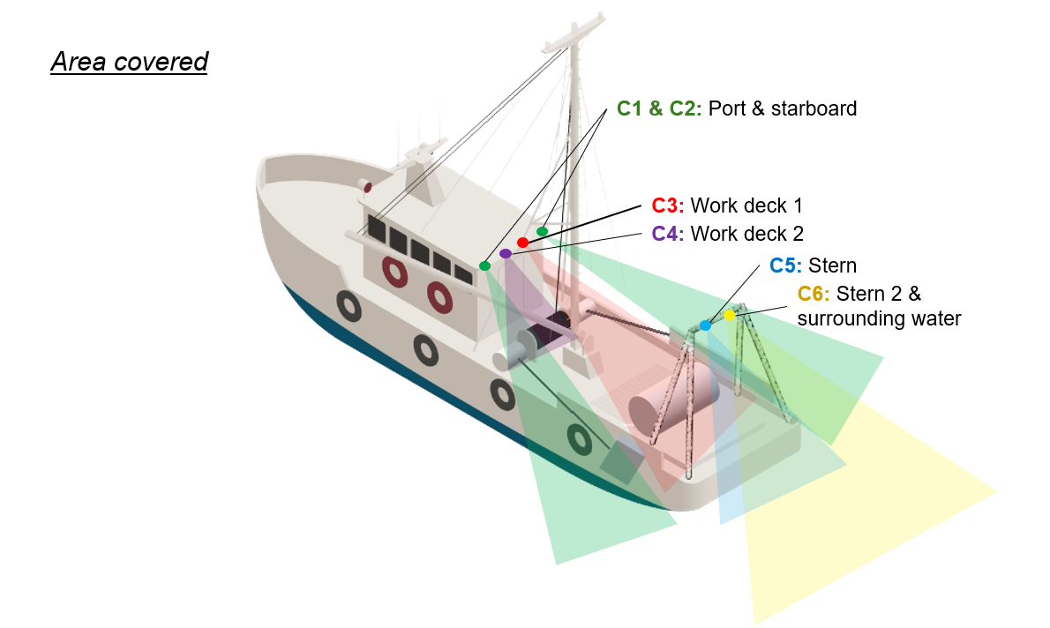
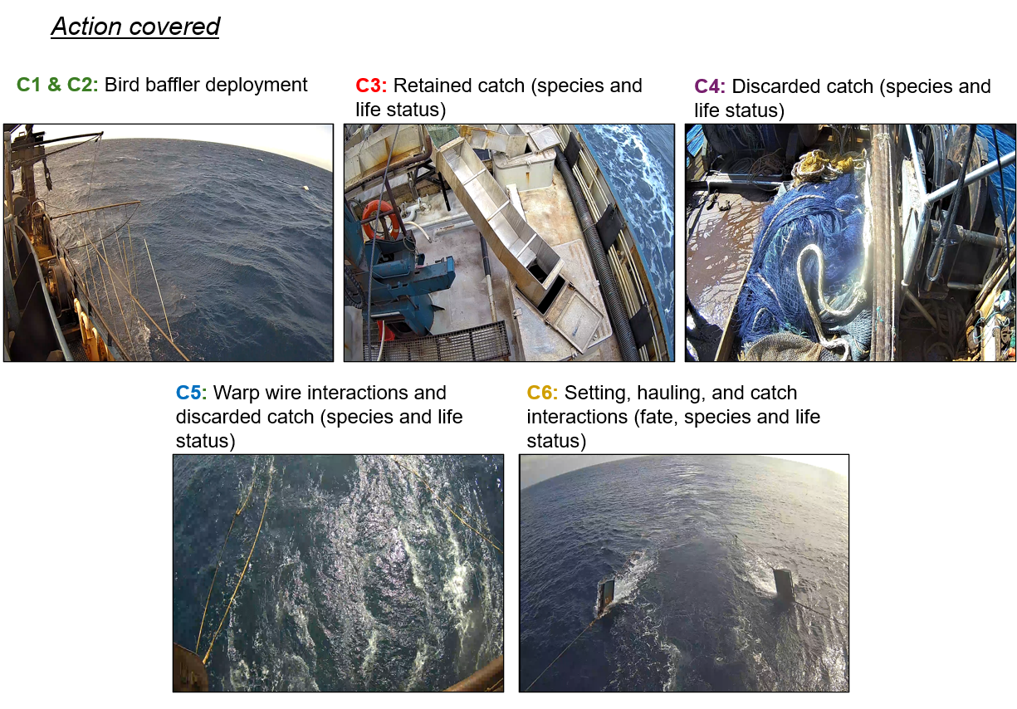
The e-monitoring system must use sensors to monitor gear activity and to activate camera recording during the start and end of setting and hauling activity. For midwater trawl vessels, the start of a set is defined from when the codend of the net is deployed into the water and ends when the warp winch rotations stop following deployment of the otter boards. The start of a haul is defined as when the warp winch rotations start to haul in the net and ends when the codend of the net is brought onboard of the vessel. Camera recording run on time must be set to 30 minutes on midwater trawl vessels to ensure catch handling practices are monitored after the completion of a haul.

